

My One Universe Network

Introduction and It Website Parts

Information Technology Database

Developed by

James L. Avakian, Engineering Technologist

Lead MERN Software Developer

http://www.MyOneUniverse.com

Five pages

Optical Automation, LLC
Technology Documentation
Software Product Division
5065 Amigo Avenue
Tarzana, CA 91356

My One Universe Network

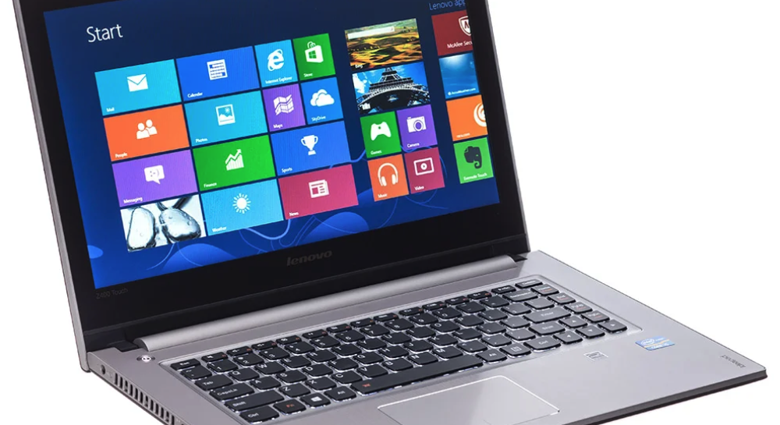

Introduction

My One Universe has both private and public Internet areas. The online social media area is American technology first created by James L. Avakian in 2020 as a place to store details such as lists. We coined the icon and website known as the ShopperLady(r) part of our MyList Network website. The network has several sections and is in “beta” test application use at this time. A reference website is AmericaDiscovered that discusses this country and what life is like.

The network was designed to equally be displayed on a computer, laptop, tablet, and cellphone without the need for a separate app from an app store. The best viewing experience is from a computer in full screen mode.

Unlike Facebook, Twitter, and xyz our new network is a novelty and a startup information technology product.

My One Universe Network

MyOneUniverse is comprised of the following:

MyList Network.com
AmericaDiscovered.com
MyEntertainmentWeb.com
MyPersonalOrganizer.com
MyTechnologyHouse.com

MyList Network.com is represented by ShopperLady and ShopperLady Today websites. The basic premise create lists of food, drugstore, office, hardware, and garden. Additional plans include more detailed information for automotive maintenance, beauty supply, and clothes buying for men, women, and kids.

AmericaDiscovered.com is a website of life in America. Sections include the government, states, and counties. Medicine, insurance, and more and where to buy it. America invented the fast food industries of American, Chinese, Italian, and more.



My One Universe Network

Advertising

Certain parts of our network is “ad-free” no advertising so you can focus on your own entertainment. Because we are trying to make the network a commercial public place everyone can enjoy we need front page advertising so we can generate revenue from your viewing. We will not show ads inside app applications. We only show advertising on the first pages and on the marketing descriptions so you can benefit from online Internet marketing and our creative app applications.

Each Website, Conclusion

Although words can describe many things from my creative thoughts, but the network is composed of several websites. Internet websites are visual, interactive, and provoke action, thus I cannot say enough about these works of programming creativity, they just must experienced first hand in a browser on your computer, tablet, or xellphone to capture the interest of these database information technology greatness.

Thank you,

James L. Avakian, Developer
Optical Automation, LLC

